Project Information RUSH REQUEST:
Date: |  |  | Respond By Date: |  |  |  | Site Drawings Available: |  |  |  |  |  | Specifications Available:
Project Name: |  |  |  |  |  |  | Funding: |  |  |  |  | End Market/Land Use:
Project City: |  |  |  | State: |  |  | Project Zip Code: |  |  |  |  | Application:
Design Status: % Complete Permitted Approved |  |  |  |  |  |  |  | Deliverable: Size/Cost Est. Proposal Drawing Quote

Structure Design Requirements
Structure Type: |  |  |  |  | Structure Shape: |  |  |  |  | Length: |  |  |  | End Area :
Design Code: |  |  |  |  |  | Live Load: |  |  |  |  |  |  | Trench or Embankment Condition:
Invert Elevation: |  |  |  | Min/Max. Span: |  |  |  |  |  |  |  |  | Reline:
Roadway Elevation: |  |  |  | Roadway Type: |  |  |  |  | Min/Max. Rise: |  |  |  | Grade Separation:
pH of water: |  |  |  | Hydraulic Report Available: |  |  |  |  |  |  |  |  | Max. HW Elevation:
Resistivity of water (Ω cm): |  |  |  |  |  | Hydraulic Considerations: |  |  |  |  |  |  | Flowline Elevation:
End Treatment
CIP Metal Modular Block Step Bevel Other
 | Length |  |  | End Elevation |  | Degree |  | Inlet End |  |  | Outlet End
Wingwall 1: |  |  |  |  |  |  |  | Top Step: |  |  | Top Step:
Wingwall 2: |  |  |  |  |  |  |  | Slope (H:V): |  |  | Slope (H:V):
Wingwall 3: |  |  |  |  |  |  |  | 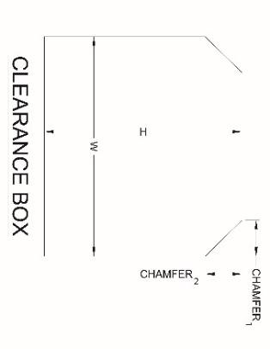  Bottom Step: |  |  | Bottom Step:
Wingwall 4:
Roadway Skew Angle: |  |  |  | Skewed Ends Required:
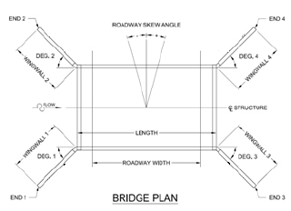

H=
W=
C₁=
C₂=

Notes

(Design Assumptions, Challenges, Constraints, etc.)

Geotechnical Data
Soil Bearing Capacity (psf): |  | _ psf Assumed Report Seismic |  |  |  | Geotechnical Report Available:
Soilside Resistivity (Ω cm): |  |  |  | Soilside pH: |  | Foundation Type:
In-Situ: | Young’s Modulus | 1) |  |  | Backfill Material: |  | 1)
Poissons’ Ratio |  | 2) |  |  |  |  | 2)
Density |  | 3) |  |  |  |  | 3)

Contact Information
Name: |  | E-mail:
Company: |  | Phone:
Address: |  | Fax:

