XBLOC COASTAL PROTECTION SYSTEM SPECIFICATIONS
Description
Xbloc is a matrix of precast concrete armor units used as a coastal protection revetment system. Xbloc units are randomly placed armor blocks. Due to the angular shape of the Xbloc, the porosity of the Xbloc armor layer is high and the concrete consumption is low.
- General
  - Scope of work
The Contractor shall furnish all labor, materials, equipment, and incidentals required for the installation of the Xbloc system in accordance with lines, grades, design, and dimensions shown on the Contract Drawings and as specified herein.

  - Designation
Precast Xbloc units manufactured in accordance with this specification shall be designated by weight in nearest whole ton.

  - Submittal
The Contractor shall furnish manufacturer’s certificates of compliance for Xbloc. The Contractor shall also furnish the manufacturer’s specifications, literature, preliminary shop drawings for the layout of the Xbloc, installation and safety instructions, and any recommendations, if applicable, that are specifically related to the project.
For any proposed alternative the Contractor shall submit to the Engineer of Record (EOR) product sizing and mean overtopping discharge in support of the proposed system stamped and signed by a Professional Engineer licensed to practice in the state where the project is located.
- Armor Units
Xbloc shall be selected using the design equations as referenced in the Guidelines for Xbloc Concept Design.

- Material
  - Concrete
The concrete for the precast blocks shall be air entrained when installed in areas subject to freeze thaw conditions, composed of Portland cement, fine and coarse aggregates, admixtures and water. Air-entrained concrete shall contain 6 +/- 2 percent air. The air-entraining admixture shall conform to AASHTO M154. The 28-day minimum compressive strength are listed in Table 3-1 below.

UNIT SIZE | ≤ 24 Tons | 24 Tons – 37 Tons | > 37 Tons
28 Day | 4000 psi | 4500 psi | 5000 psi

    - Portland cement
Shall conform to the requirements of ASTM Specifications C150 for Type I, Type II, or Type III cement.
    - Blended Cement
Shall conform to the requirements of ASTM specification C595 for Blended Hydraulic Cements.
    - Coarse Aggregate
Aggregate shall meet requirements for ASTM C33.
    - Water Reducing Admixture
The manufacturer may submit, for approval, by the Engineer, a water reducing admixture for the purpose of increasing workability and reducing the water requirement for the concrete.
    - Calcium Chloride
The addition to the mix of calcium chloride or admixtures containing calcium chloride will not be permitted.
    - Mixture
The aggregates, cement and water shall be proportioned and mixed in a batch mixer to produce a homogeneous concrete meeting the strength requirements of this specification.

- Manufacturing of Precast Xbloc
  - Molds
The Xbloc units will be produced with pre-manufactured molds and will be suitable for materials listed in section 3.1.
  - Unit Marking
The Xbloc units will be marked with the following indicators. The markings will consist of:
- Unique serial number
- Block Size

- Underlayer Preparation
  - Rock Quality and Gradation
    - Quality
The mass of the under layer should be between 1/15th to 1/6th of the selected unit mass. The rock quality of the under layer shall be tested at the start of the project, followed by one test every 1500 FT of project length or 5500 Tons whichever comes first, or as required by the site quality engineer or EOR.

The following rock quality requirements apply:
- Mass density shall be above 156 lb/ft³;
- Water absorption shall be below 3%;
- Breakage: uniaxial compressive strength shall conform to ASTM C170;
- Wear: Resistance to degradation shall conform to ASTM C535;
- Salt crystallization: The resistance to salt crystallization shall conform to ASTM C88. If water absorption is below 0.5% no testing is required;
- Freeze/Thaw: when climatically relevant the material shall conform to ASTM C5312. If water absorption is below 0.5% no testing is required;
- Block integrity: blocks shall be free from cracks, cleavage planes, seams and other defects as observed by regulated, reported visual inspection.
    - Gradation
The rock gradation of the under-layer material shall be tested at the start of the project, followed by one test every 1500 FT of project length or 5500 Tons whichever comes first, and shall comply with design, or as required by the site quality engineer or EOR.
  - Profile
The Contractor shall prove the suitability of the under-layer profile. The under layer of each section shall be profiled prior to placement of the armor layer in order to ensure a smooth surface for proper Xbloc placement. The contractor shall keep measurements for inspection and project EOR records.

Cross profiles shall be measured every 30 Feet along the structure perimeter with level measurements along each cross profile at a distance Z and is defined by Z_{n50} = (W₅₀/ρ_{rock})^{1/3}. Reference Figure 6-1. The criteria for the profile of the under-layer and toe are:
- The minimum thickness of the under layer is 2 D_{n50}.
- The placement tolerance around the design profile is +/- 0.5 D_{n50}.
- Succeeding measurements within a measurement profile shall not deviate more than 0.3 D_{n50}.
The first criterion defines the minimum thickness of the under-layer. To demonstrate its thickness, the contractor shall use the survey of the under-layer and the survey of the underling rock layer.
The second criterion defines how close the profile shall be compared to the designed profile.
The third criterion defines how smooth the surface shall be.

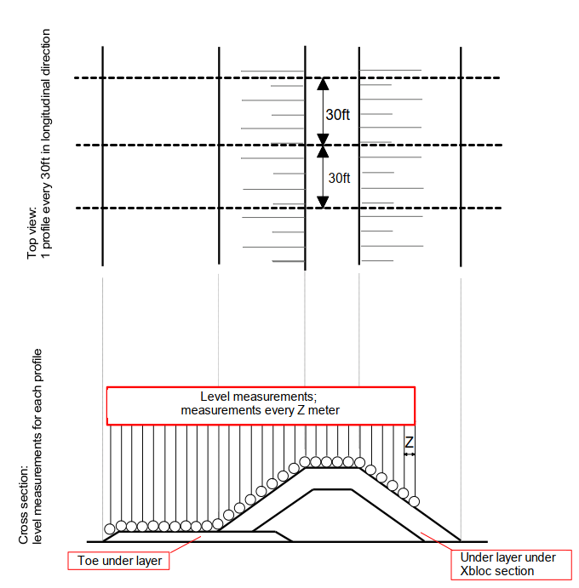
Figure 5-1: Under-layer cross-profile measurements

- Block Placement
  - General
Blocks shall not be placed on the structure before the concrete has reached a compressive strength per table 3-1 and before the concrete has cured for 2 weeks.

Blocks shall not be placed on the structure before the temperature difference between the core of the unit and the seawater is lower than 36°F.

Blocks shall not be placed on the structure if damage due to handling and transport exceeds 1% of the block volume.

The Contractor shall place the blocks according to the coordinates supplied by the EOR. The as-built coordinates shall be logged in a file.

  - Base Row: Xbloc
The Xbloc base row shall be placed with a tolerance of 0.1H_{x} (where H_{x} is the characteristic unit height of the Xbloc armor unit) in relation to the theoretical position determined by the EOR.

    - Option 1: First Row consists of XBase
If the first row consists of Xbase Units, these units shall meet the following criteria:
- The units shall be placed flat
- The units in the first row shall be placed to the position shown on the layout drawings with an accuracy of plus or minus 0.1H_{x} (where H_{x} is the characteristic Xbloc height).
- The units shall be placed with a regular orientation as shown in Figure 6-1.
The first row of Xbloc placed on top of the Xbase units shall meet the following criteria:
- The units shall rest on 3 points as shown in Figure 6-1.
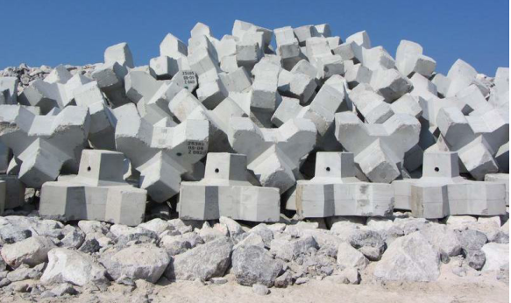
- The units in the first row shall be placed to the position shown on the layout drawings to an accuracy of 0.1H_{x} (where H_{x} is the characteristic Xbloc height).
Figure 6-1: Regular placement of Xbase units and Xbloc units

    - Option 2: First Row consists of XBloc
Units shall be placed with regular orientations as shown in Figure 6-2.
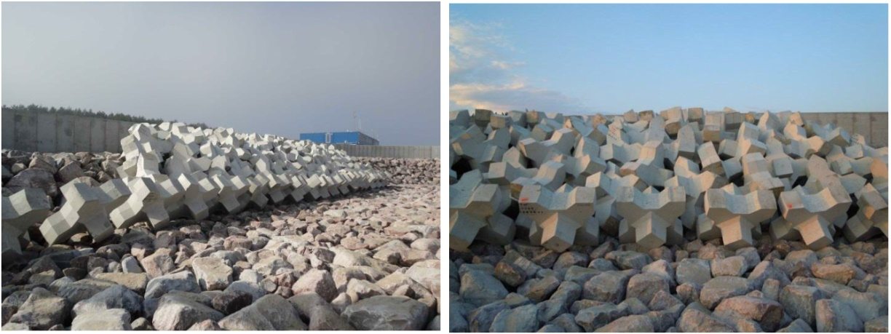
Figure 6-2: Regular placement of Xbloc units in first row

The units in the first two rows shall be checked every 30FT or 5 units whichever comes first, in order to prevent difficulties in placement of the units higher up on the slope.
The rock toe shall be accurately placed in good condition with the armor layer. This shall be done as early as practically possible after placement of the 3rd row of armor units.

  - Remaining units on the slope
For the remaining rows on the slope, the placement shall meet the following criteria:
- The units have randomly varied orientation hence there shall not be multiple neighboring units with similar orientations;
- Every Xbloc element in a trunk section is secured by the elements in the row above and by contact with the under layer;
- The relative packing density (RPD) on the slope shall be between 98% and 105% of the theoretical packing density referenced in section 6.6.2.

  - Units on the crest
Xbloc units on the crest shall be placed either on 2 legs or resting on 3 points and shall form a good interlocking connection between the Xblocs on the slope and concrete crown wall, crest armor protection or, if the crest is covered with Xblocs, with the rear armor.

If voids remain between a crown call and the last Xbloc on the crest, which are too big to fit another Xbloc, these voids shall be filled with large rock, large grout bags or Xbase units in order to obtain good connection between the Xbloc layer and the crown wall.

  - Placement trial on land
If required by the EOR the Contractor, the contractor shall perform a placement trial on land. Suggested requirements of the test section are as follows or as directed by the EOR.
The requirements for the test section are:
- The rock grading used underneath the toe shall be equal to the rock grading used in the toe of the structure;
- The slope shall be high enough to fit 5 rows of blocks.
- The slope width shall be wide enough to fit 6 blocks in the first row.
- The slope steepness shall be equal to the slope steepness of the structure;
- The rock grading used for the slope shall be equal to the rock grading used in the under layer of the structure;
The under layer profile shall meet the required tolerance as described in section 6.2. An example of a trial placement setup is presented in Figure 6-3.
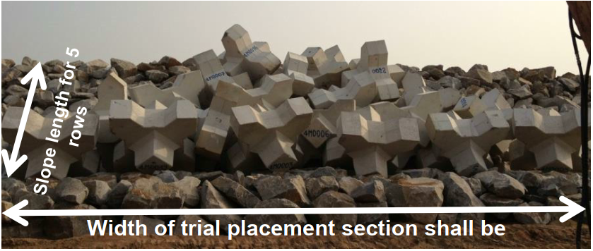
Figure 6-3: Trial Placement Setup

  - Quality Control
The main aspects to check after completion of a breakwater section are:
- Interlocking
- Packing Density

    - Survey on interlocking
The Contractor shall provide survey coordinates for projects 100,000 SF and over or if required by the EOR. The survey shall consist of coordinates of underwater and above water units.

The underwater survey report shall be done with suitable equipment and/or divers. The report shall contain information from which it can be derived whether all units are properly interlocking (all units secured by the units above) and/or digital images of the armor layer in adequate detail to assess the interlocking.

The above water survey shall contain a series of clear high-resolution digital photos or a high-resolution video. The photos/video shall be taken during low water looking at the structure from the seaside perpendicular to the structure. A high camera position is required in order to give a clear view on the armor layer. On the photos no more than 10 units in width shall be depicted. The units at the boundaries of each placement section shall be clearly marked on the photos. The needed section shall be photographed in a series overlapping photos. The stationing numbers indicated along the crest of the structure shall be clearly visible on the photos.

    - Relative packing density
The Contractor shall log the location of each Xbloc units in the placement log file.

The packing density shall be determined by:

$$RPD = \frac{(N_{x }-1)(N_{y}-1)d_{x}d_{y}D^{2}}{L_{x}L_{y}} × 100\%$$

With:

RPD [%] Relative Packing Density
N_{X} [-] Horizontal number of units along the control section
N_{Y} [-] Number of horizontal rows
d_{X} [-] Horizontal distance coefficient
d_{Y} [-] Upslope distance coefficient
D [ft] Characteristic height of Xblocs
L_{X} [ft] Horizontal length of section
L_{Y} [ft] Length up the slope along the slope

The distance L_{Y} is the average distance between the units in the first row of the (sub) section and the units in the top row of the (sub) section.
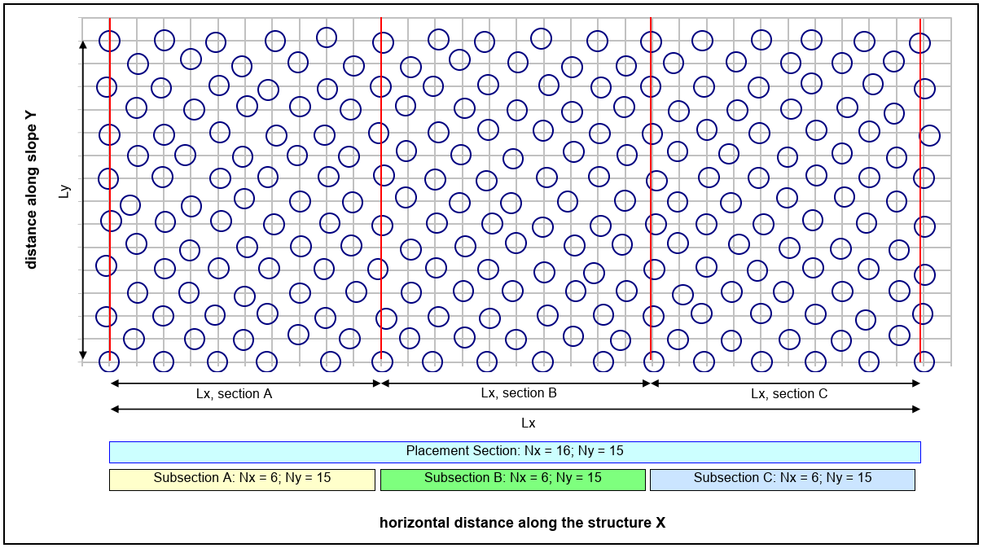
Figure 6-4: Example of placement section (N_{Y} = 15)

For complicated sections such as transitions between different unit sizes, curved sections and the breakwater head, the EOR will determine the packing density based on the EOR’s judgement and experience.

