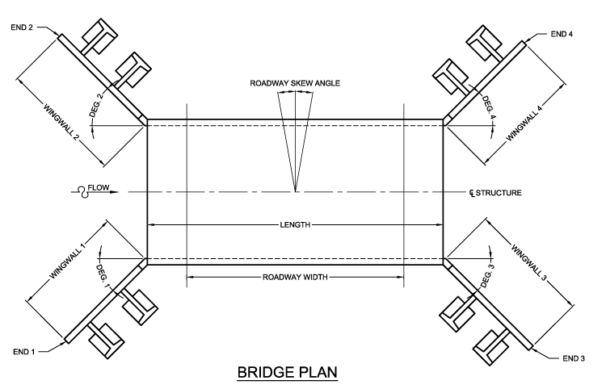
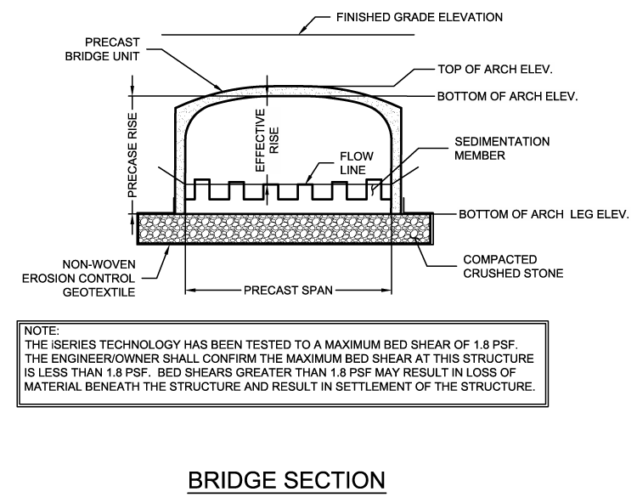

Project Information RUSH REQUEST:
Date: |  |  | Respond By Date: |  |  |  | Site Drawings Available: |  |  |  |  |  | Specifications Available:
Project Name: |  |  |  |  |  |  | Funding: |  |  |  |  | End Market/Land Use:
Project City: |  |  |  | State: |  |  | Project Zip Code: |  |  |  |  | Application:
Design Status: % Complete Permitted Approved |  |  |  |  |  |  |  | Deliverable: Eng. Est. Proposal Dwg. DYOB Other

Design & Loading Requirements
Span (ft): |  |  |  |  |  |  |  |  |  | Effective Rise (ft): |  |  |  |  |  |  |  |  |  |  |  |  | Length (ft):
Loading: |  |  |  |  |  |  |  |  |  |  | Design Code: |  |  |  |  |  |  |  |  |  |  | Regulatory Agency:
Soil Bearing Capacity (psf): |  |  |  |  |  |  |  |  |  | psf |  | Assumed Report |  |  |  |  |  |  | Geotechnical Report Detail:
Hydraulic Modeling / Data Available:
Formliner: |  |  |  |  |  |  | Large Blockouts/Utility Openings: |  |  |  |  |  |  |  |  |  |  |  |  |  |  |  |  | Epoxy/ Other Rebar:
Headwall Height (ft): |  |  |  |  |  | Upstream |  |  |  |  |  | Downstream |  |  |  |  | Thickness Sloped |  |  |  |  |  |  |  | Wall Geometry Unknown; Assume |  |  |  |  |  |  |  |  | :1 Grading
Wingwalls: |  |  |  |  |  |  |  |  | Headwalls: |  |  |  |  |  |  |  |  |  |  | Finished Grade Elevation (ft): |  |  |  |  |  |  |  |  |  |  | Min / |  |  |  | Max
Dimensions & Elevations
 | Length |  |  | End Elevation |  | Degree |  |  | Upstream |  | Downstream
Wingwall 1: |  |  |  |  |  |  |  | Flow Line:
Wingwall 2: |  |  |  |  |  |  |  | Top of Arch:
Wingwall 3: |  |  |  |  |  |  |  | Bottom of Arch:
Wingwall 4: |  |  |  |  |  |  |  | Bottom of Leg:
Roadway Skew Angle: |  |  |  | Skewed Ends Required: |  |  |  | Bottom of Footing:

Notes (Design Alternatives, Design Assumptions, Challenges, Constraints, etc.)

Contact Information
Name: |  | E-mail:
Company: |  | Phone:
Address: |  | Fax:

